IMT Worksheet 1

All your answers should be in a word document saved in a Git repository under your username. Submit your answers by sending a link to your git repository as a reply to your email.

Define the following concepts using screenshots and text:

* Repository

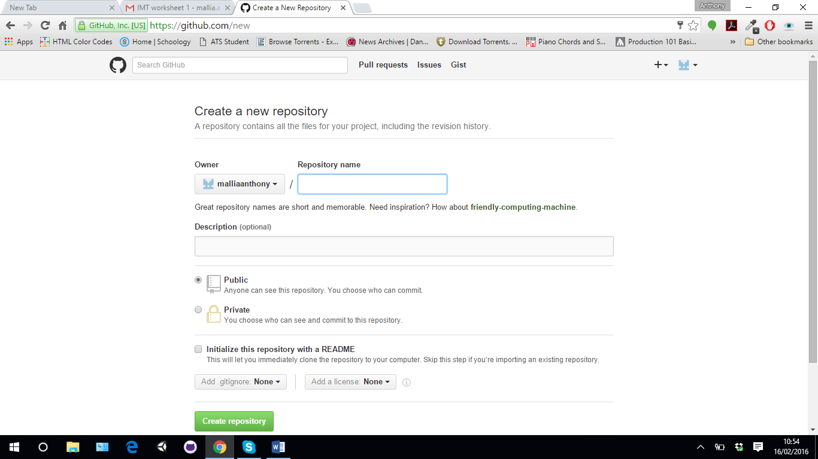

This is the repository part of github. It is a means of storage space when one can access his/her projects through any different versions of github.

* Commit

Commit, or "revision", is an individual change to a file (or set of files). It's like when you save a file, except with Git, every time you save it creates a unique ID (a.k.a. the "SHA" or "hash") that allows you to keep record of what changes were made when and by who. Commits usually contain a commit message which is a brief description of what changes were made.

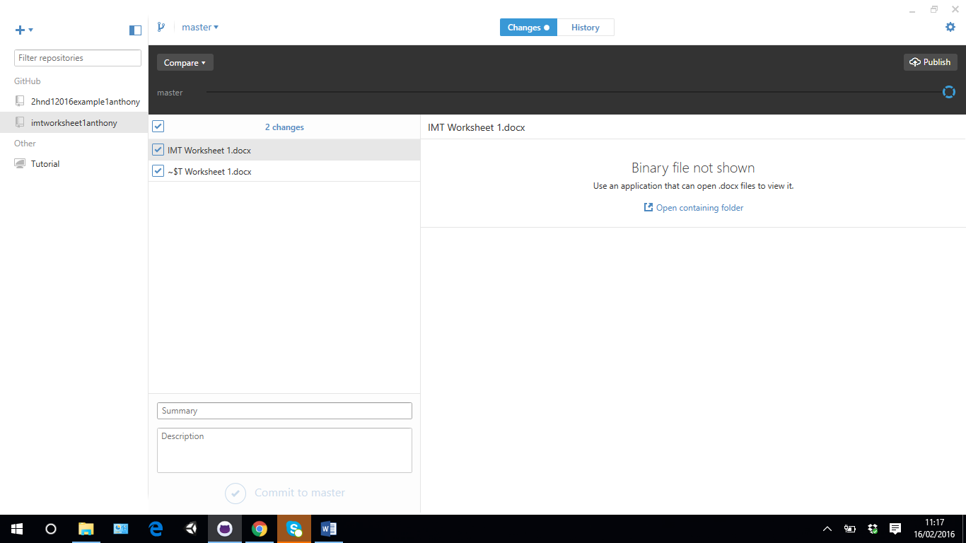

* 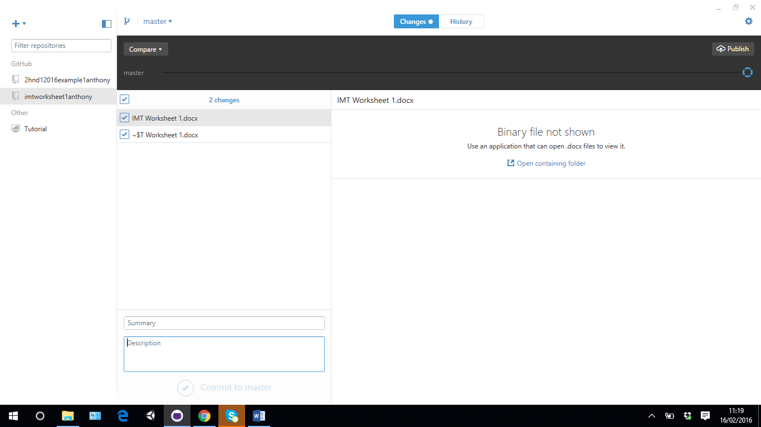Commit description

The user is able to offer any kind of description to any document so that if one decided to continue on such project he/she are able to know on what they are working.

* Github desktop

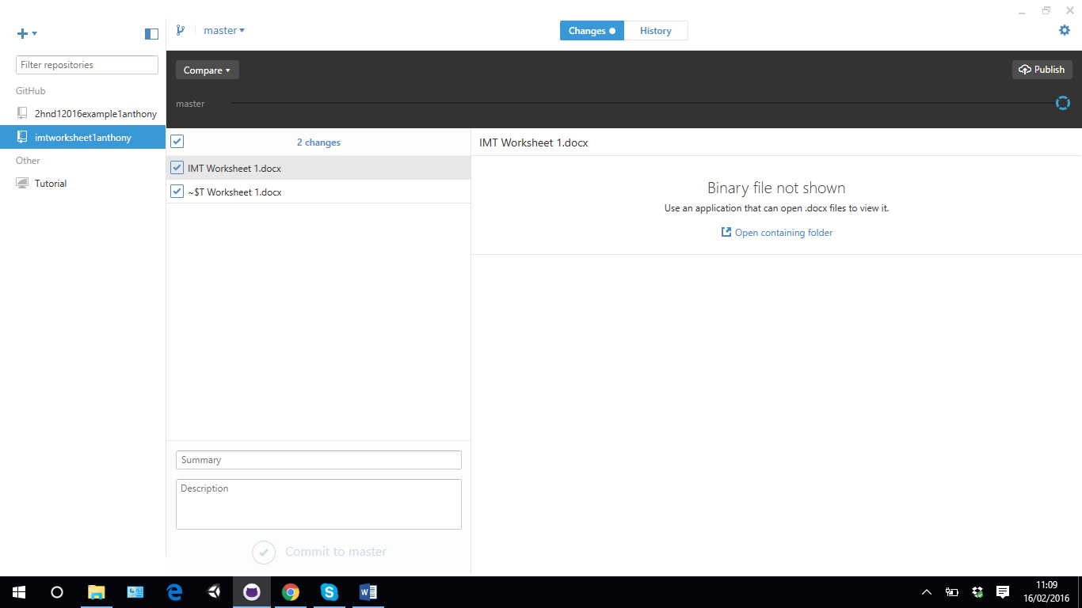

This can be a desktop version for Windows and Mac. One can able to work from the desktop version by cloning the file created on the github website. One can re upload to the github website once ready.

* 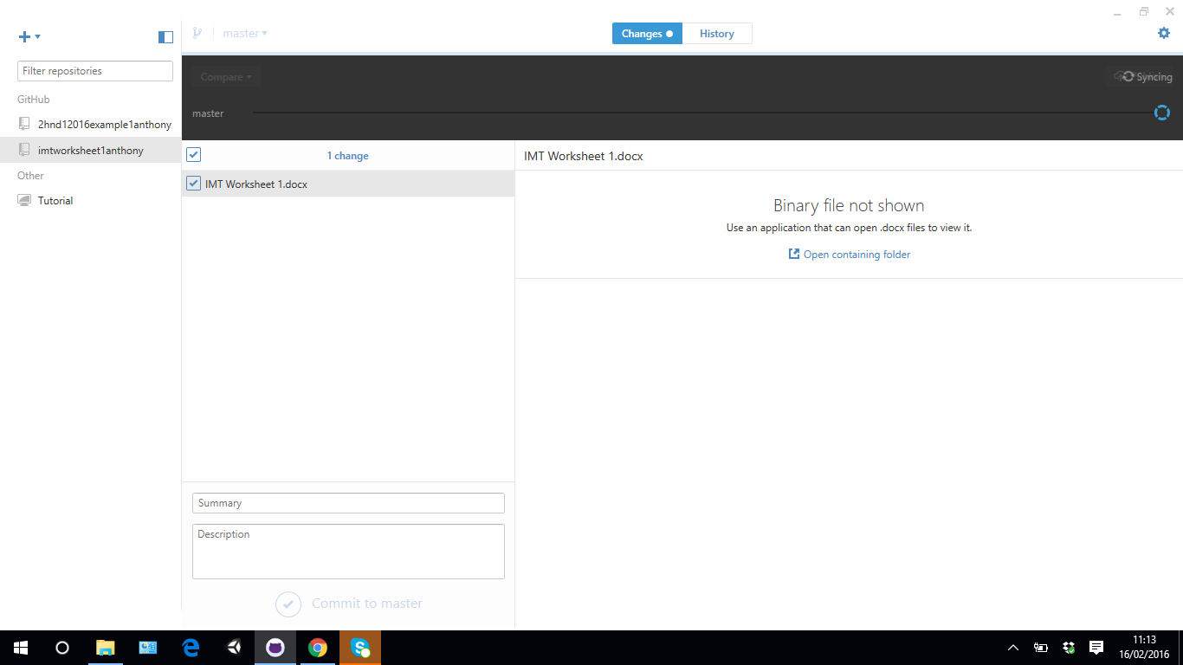Git Sync

Once the user enters a summary and a description then the user will be able to publish the document on the github website.

* What ‘download zip’ does.

It is a button where the user is able to see the document shared with the public.

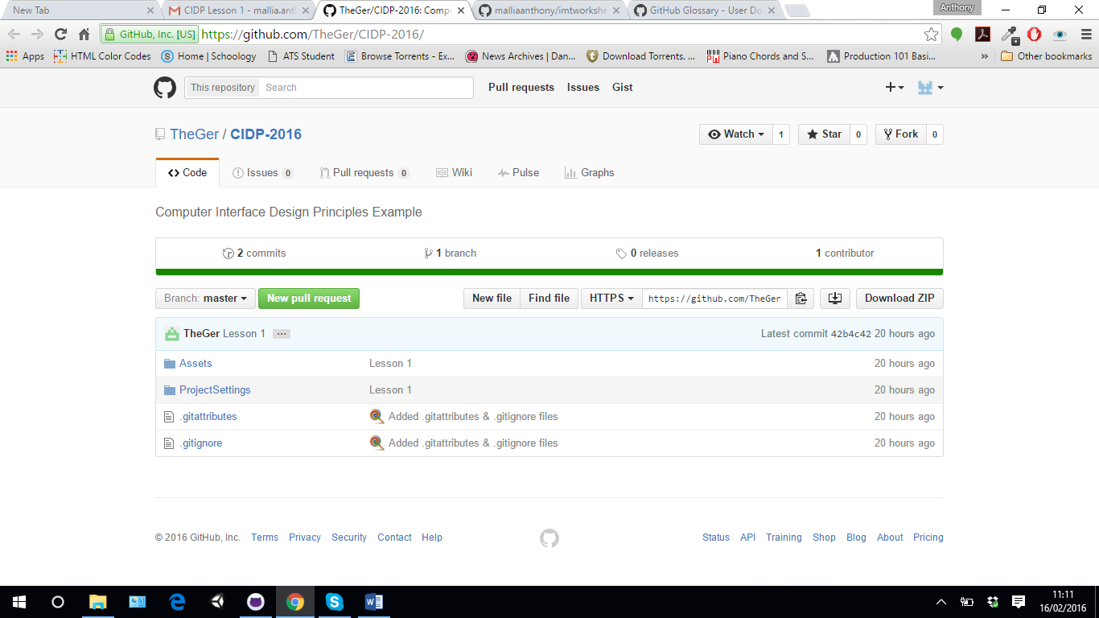

Create a word document and sync it to your Git repository.